

Faculty of Engineering

Ain Shams University

**CSE225: Software Testing, Validation, and Verification**

**Final Project: Online Banking**

|  |  |
| --- | --- |
| **Team Members** | |
| **ID** | **NAME** |
| **17p3051** | **Mennat – Allah Ashraf Fouad Fetouh** |
| **18P8814** | **Youssef Mahmoud** |
| **17P6035** | **Ahmed Fawzy Amer** |
| **16P6035** | **Samy Samir Mohamed** |
| **19P1863** | **Mark Sameh Samier** |

***Submitted to:***

**Prof. Dr. Islam El-Maddah**

# ONLINE BANKING:

Our project consists of 5 main sections:

1. Pre GUI code with testing.
2. GUI code with GUI testing.
3. Errors and fixing.
4. GUI code after Fixing Errors.
5. Performance Testing.

Codes included in the files attached with the report.

This report includes GUI testing with scenarios and testcases, Errors & Fixing, and performance testing.

# REPOSITORY of Project:

<https://github.com/Mennah-Ashraf/Testing-Project.git>

# Aim of GUI Testing

Graphical User Interface (GUI) is the interface of the program that the user will see and interact with. GUI can be in the form of a web page or a program, the latter is the case for our online banking app.

GUI top layer is responsible for dealing with user events and redirects these events and activities to the correct block of code responsible for the meant request using method calls.

**Testing Methodology**

Our code was developed by 2 of our team members, while the rest were concerned about testing. In the case of GUI testing in this section, we are conducting a ***black-box*** approach. I -the tester- am testing the software without looking at the code, since I’m concerned with what the end-user will be dealing with.

The acceptance test will be conducted using ***Manual-Based Testing***, we will be testing the states and actions of the system using previous experience of dealing with such software systems. Another reason why we choose manual testing is that the software size is relatively small and there is a small number of states possible in the system, so the overhead of introducing test drivers or bots is not justifiable.

The coverage model of the test will be based on the State-Based model; All states of the GUI will be tested at least once. The test will be conducted using Finite State Machine (FSM) where each state is a window of the program, and the states change based on user events.

**List of Scenarios:**

1. Scenario 1: Customer application to the system.
2. Scenario 2: Admin login and functionalities.
3. Scenario 3: Customer login and functionalities.
4. Scenario 4: Exercising Application form and Check Request Status.

# Scenario 1: Application

Please Zoom-in to fully see the diagram.

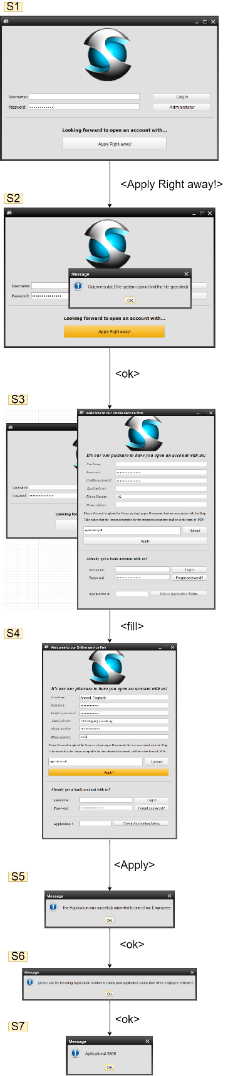

Figure 1: GUI Application - Scenario 1

# Scenario 1 Description

The user in this scenario tries to apply to our online banking system. A user is required to fill a form then apply the application. The application will be approved or rejected later by one of the system admins.

# Scenario 1 Table

|  |  |  |  |
| --- | --- | --- | --- |
| Current State | Event | Next State | Errors Detected |
| S1 | Click on “Apply Right Away” | S2 | A warning windows was shown that an end-user shouldn’t see. |
| S2 | Click on “Ok” | S3 | This state should not exist. |
| S3 | Fill Form | S4 | None. |
| S4 | Click on “Apply” | S5 | None. |
| S5 | Click on “Ok” | S6 | None. |
| S6 | Click on “Ok” | S7 | None. |
| S7 | Click on “Ok” | - | None. |

# Scenario 2: Admin Login and Functions

Please Zoom-in to fully see the diagram.

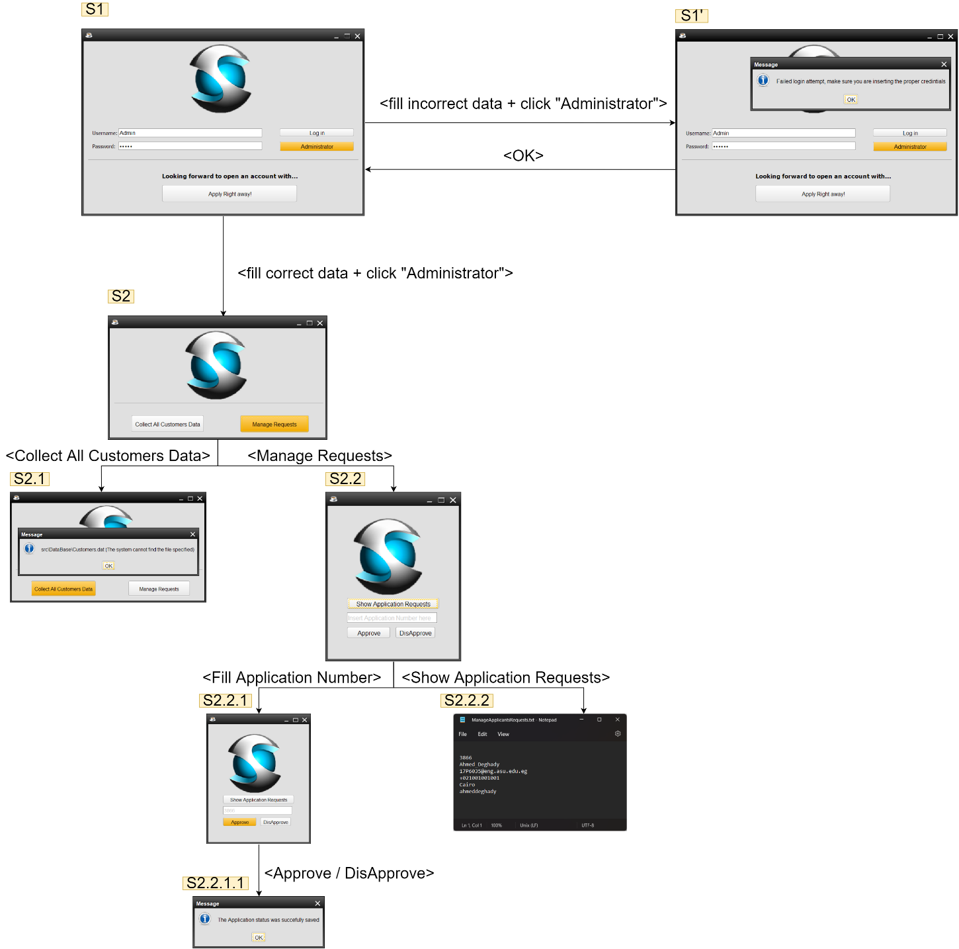

Figure 2: Admin GUI - Scenario 2

# Scenario 2 Description

The admin in this scenario logs in then redirected to the admin functionalities screen. An admin can collect all customers data or manage applications.

# Scenario 2 Table

|  |  |  |  |
| --- | --- | --- | --- |
| Current State | Event | Next State | Errors Detected |
| S1 | Fill incorrect data + click “Administrator” | S1’ | None. The user should see an error upon entering incorrect credentials |
| S1 | Fill correct data + click “Administrator” | S2 | None. |
| S1’ | Click on “Ok” | S1 | None. |
| S2 | Click on “Collect All Customers Data” | S2.1 | Error window appears that the admin shouldn’t see. The admin should be able to see the customers data which we know they already exist from scenario 1 (this test case is exercised after the customer is already approved). |
| S2 | Click on “Manage Requests” | S2.2 | None. |
| S2.1 | Click on “OK” | S2 | This state should not exist in this way. This is a bug that the developers must address. |
| S2.2 | Fill Application Number | S2.2.1 | None. |
| S2.2 | Click on “Show Applications Requests” | S2.2.2 | None. |
| S2.2.1 | Click on “Approve / DisApprove” | S2.2.1.1 | None. |
| S2.2.1.1 | Click on “Ok” | S2.2.1 | None. |
| S2.2.2 | - | - | None |

# Scenario 3: Customer Login and Functions

Please Zoom-in to fully see the diagram.

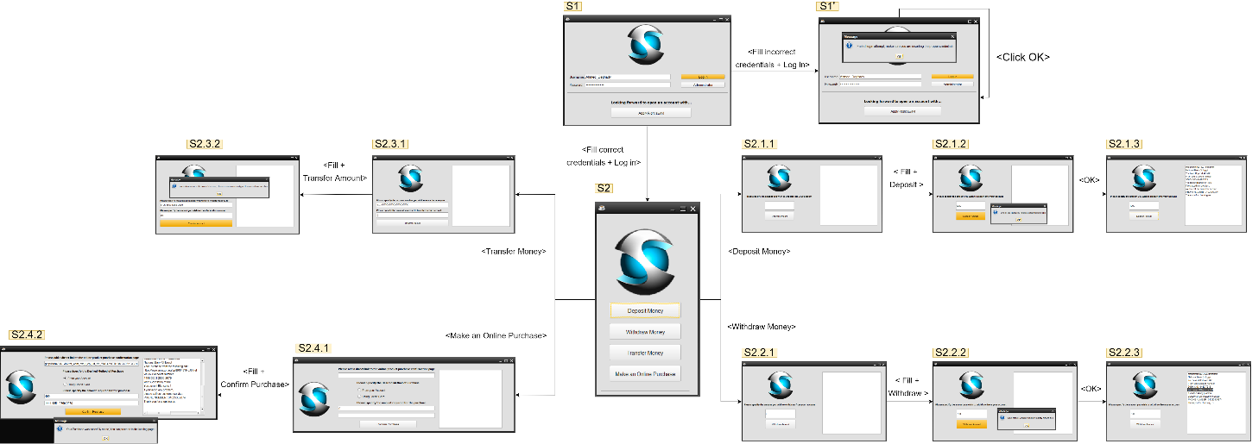

Figure 3: Customer GUI - Scenario 3

# Scenario 3 Description

The user in this scenario logs in then redirected to the user functionalities screen. A customer can deposit, withdraw, transfer money, and make online purchases.

# Scenario 3 Table

|  |  |  |  |
| --- | --- | --- | --- |
| Current State | Event | Next State | Errors Detected |
| S1 | Fill incorrect data + click “Log in” | S1’ | None. The user should see an error upon entering incorrect credentials |
| S1 | Fill correct data + click “Log in” | S2 | None. |
| S1’ | Click on “Ok” | S1 | Infinite Loop, the user can’t escape from this state. This fatal bug should be addressed by the developers as soon as possible. |
| S2 | Click on “Deposit Money” | S2.1.1 | None. |
| S2 | Click on “Withdraw Money” | S2.2.1 | None. |
| S2 | Click on “Transfer Money” | S2.3.1 | None. |
| S2 | Click on “Make an Online Purchase” | S2.4.1 | None. |
| S2.1.1 | Fill + Deposit | S2.1.2 | A warning message that the customer shouldn’t see. |
| S2.1.2 | Click “OK” | S2.1.3 | None |
| S2.1.3 | - | - | None |
| S2.2.1 | Fill + Withdraw | S2.2.2 | A warning message that the customer shouldn’t see. |
| S2.2.2 | Click “OK” | S2.2.3 | None. |
| S2.2.3 | - | - | None. |
| S2.3.1 | Fill + Transfer Amount | S2.3.2 | Operation failure. The account number belongs to another account in the system that we know it exists, but the operation was rejected. This bug is a result of another bug discovered in scenario 4 where creating new accounts removes other customers details. |
| S2.3.2 | - | - | This State should not exist |
| S2.4.1 | Fill [From Account] + Confirm Purchase | S2.4.2 | None. |
| S2.4.2 | - | - | None. |
|  |  |  |  |

# Scenario 4: Exercising Application form and Check Request Status

Please Zoom-in to fully see the diagram.

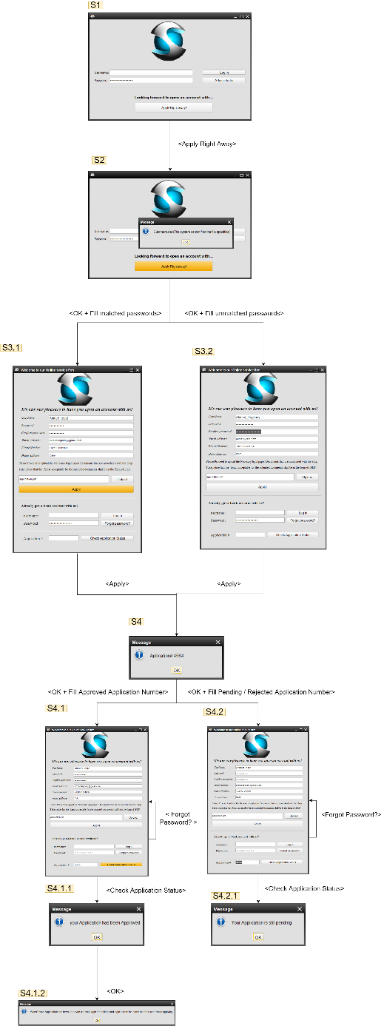

Figure 2: Form GUI - Scenario 4

# Scenario 4 Description

The user in this scenario exercises the rest of the options in the application form and checks for application request numbers to see if they are approved, rejected, or pending.

# Scenario 3 Table

|  |  |  |  |
| --- | --- | --- | --- |
| Current State | Event | Next State | Errors Detected |
| S1 | Apply Right Away | S2 | A warning windows was shown that an end-user shouldn’t see. |
| S2 | OK + Fill matched Passwords | S2.3.1 | None. |
| S2 | OK + Fill unmatched Passwords | S2.3.2 | None. |
| S3.1 | Apply | S4 | None |
| S3.2 | Apply | S4 | User should see error message rejecting the application since the passwords are unmatched. Instead, the form was submitted successfully. |
| S4 | OK + Fill Approved Application Number | S2.4.1 | None. |
| S4 | OK + Fill Pending / Rejected Application Number | S2.4.2 | None. |
| S4.1 | Check Application Status | S4.1.1 | None. |
| S4.1.1 | OK | S4.1.2 | None. |
| S4.1.2 | - | S4.1 | None. |
| S4.1 | Forgot Password? | S4.1 | Another window was expected to open in order to reset the password, but nothing has appeared. The button has no functionality attached to it. |
| S4.2 | Forgot Password? | S4.2 | Another window was expected to open in order to reset the password, but nothing has appeared. The button has no functionality attached to it. |
| S4.2 | Check Application Status | S4.2.1 | None. |
| S4.2.1 | - | S4.2 | None. |

# Non-GUI Testcases

Program accepts/rejects application request numbers that does not even exist.

When you create a new account, all previous accounts’ data are erased and they cannot do any operations on their accounts, but they only can still login (even after clicking login the app shows an error message, it still redirects to the main functionalities section).

# ERROR FIXING:

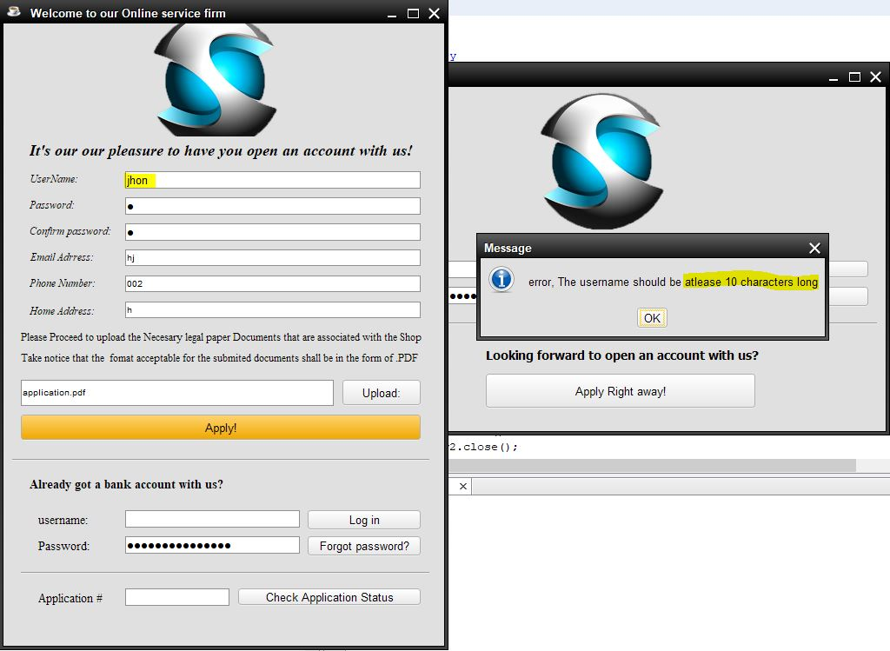

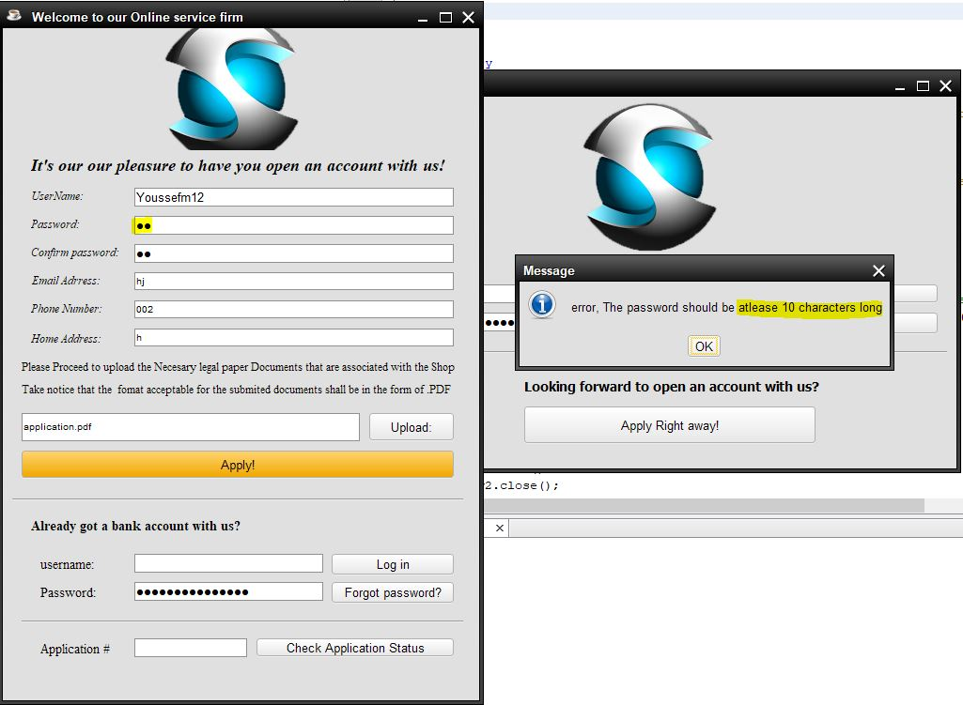

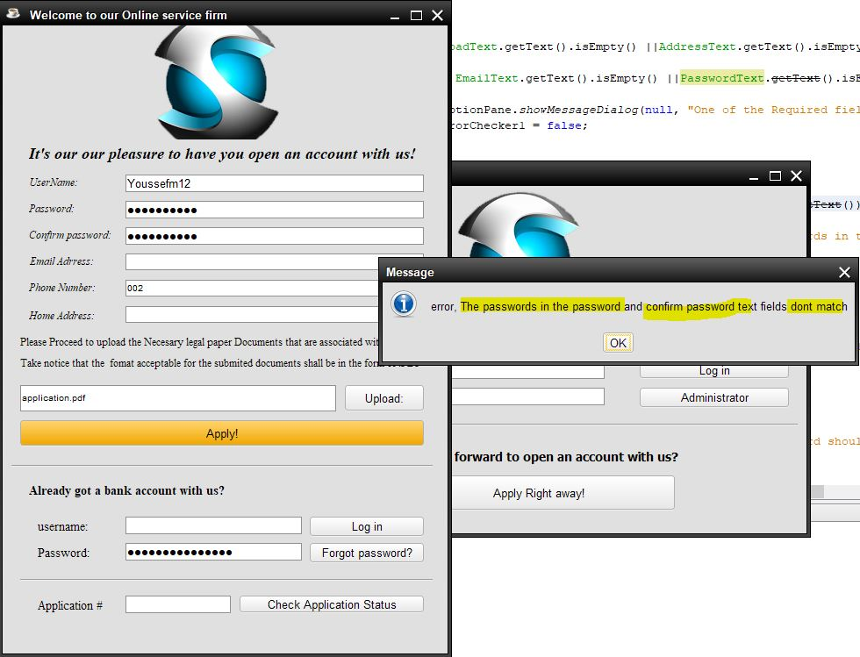

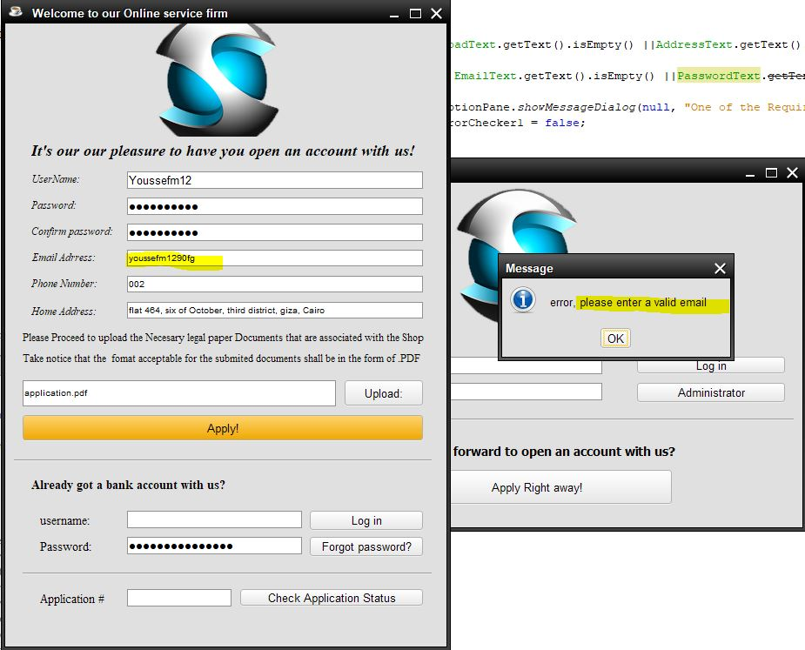

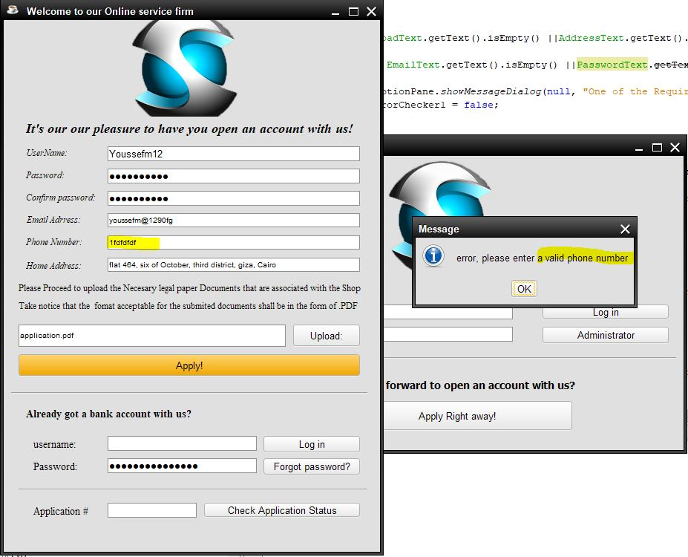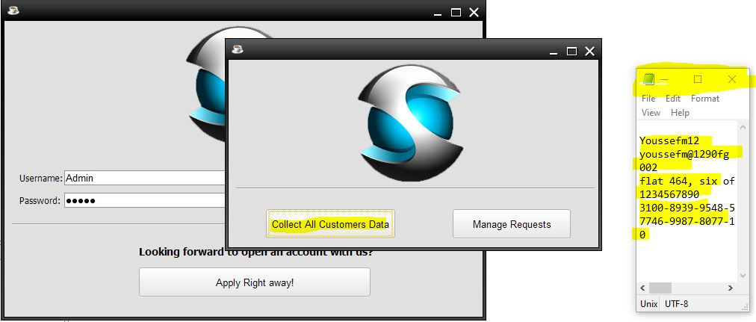

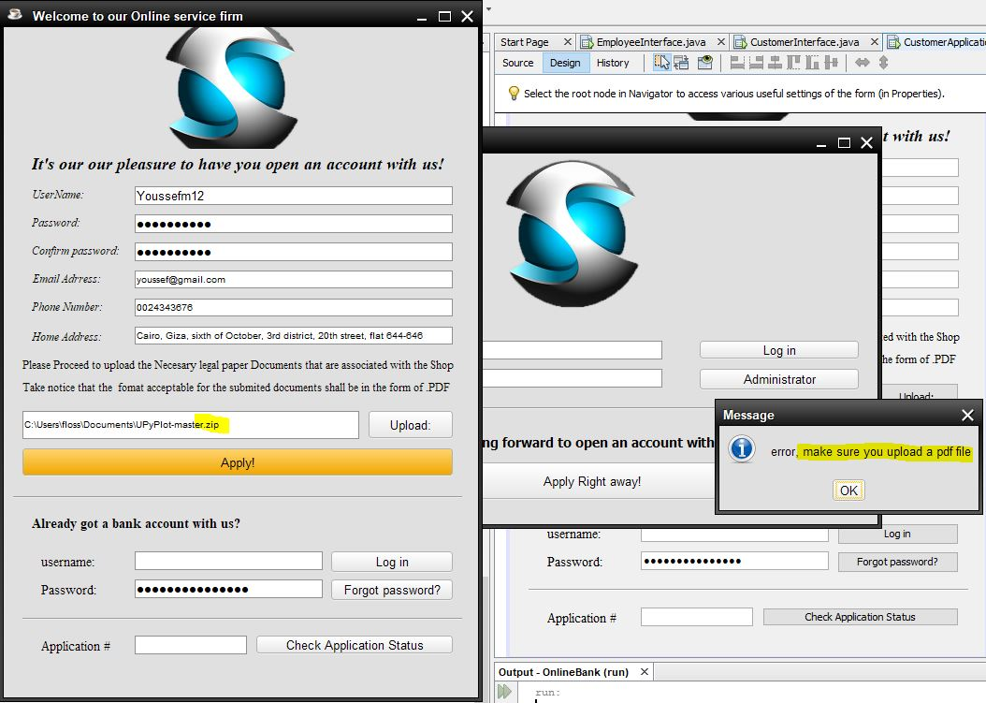

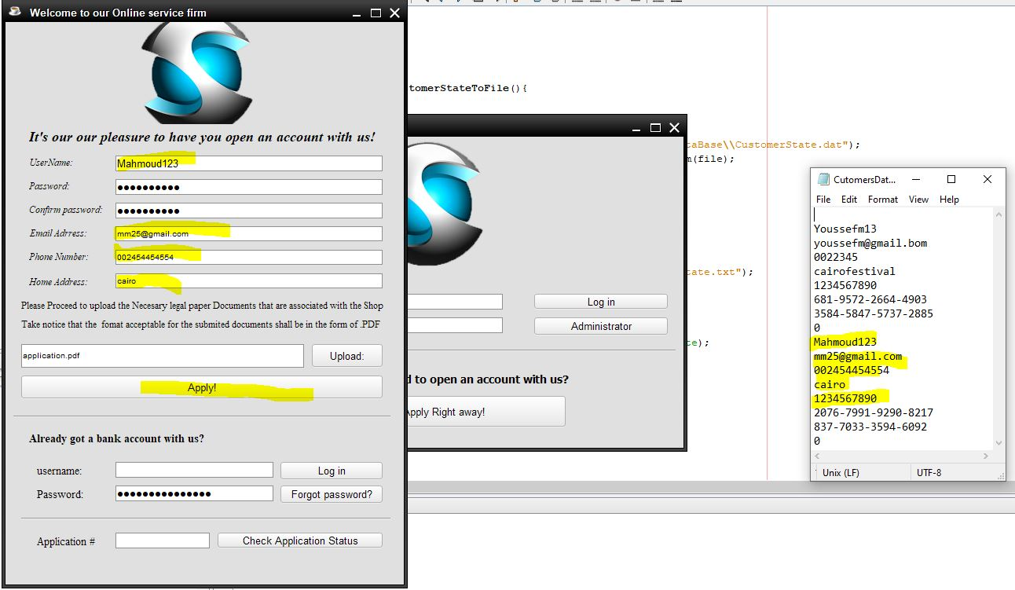

PERFORMANCE TESTING:

Determining response time between each action , when the benchmark is small number that’s means we have higher performance.

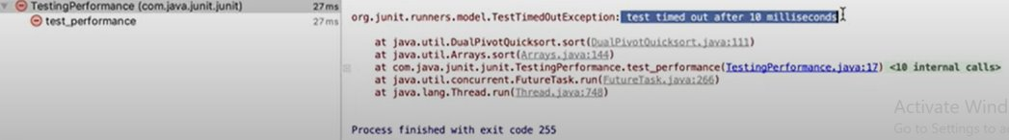 So, the performance of our project is high.